University Curriculum Committee

Proposal for New Course

1. Is this course being proposed for Liberal Studies designation? Yes No X
If yes, route completed form to Liberal Studies.
2. New course effective beginning what term and year? (ex. Spring 2008, Summer 2008) |  |  |  |  |  |  |  |  |  |  |  |  |  |  |  |  |  |  |  |  |  |  |  |  |  |  |  |  | Summer 2007
See effective dates schedule.
3. College |  | School of Health Professionals Consortium of Professional Schools |  |  |  |  |  |  |  |  | 4. Academic Unit |  |  |  |  |  |  |  |  |  |  |  |  |  |  |  | Dental Hygiene
5. Course subject/catalog number |  |  |  |  |  | DH-496 |  |  |  |  |  |  |  |  |  |  |  |  |  |  |  |  | 6. Units |  |  |  |  |  |  |  | 3
7. Co-convened with |  |  |  | DH-596 |  |  |  |  |  |  |  |  |  |  |  |  |  |  |  |  |  |  |  | 7a. Date approved by UGC
(Must be approved by UGC prior to bringing to UCC. Both course syllabi must be presented.)

8. Cross-listed with
(Please submit a single cross-listed syllabus that will be used for all cross-listed courses.)
9. Long course title |  |  | Beyond Cultural Diversity
(max 100 characters including spaces)
10. Short course title (max. 30 characters including spaces) |  |  |  |  |  |  |  |  |  |  |  |  |  |  |  |  |  |  | Beyond Cultural Diversity
11. Catalog course description (max. 30 words, excluding requisites).
Provides a background in multicontextuality and best practices for teaching all students. The concepts presented are targeted toward and specifically adapted to Allied Health and Nursing education.

12. Grading option: Letter grade |  |  |  |  |  |  | X |  |  | Pass/Fail |  |  |  |  |  |  |  |  |  | or Both
(If both, the course may only be offered one way for each respective section.)
13. Is this a topics course? Yes No
14. May course be repeated for additional units? |  |  |  |  |  |  |  |  |  |  |  |  |  |  |  |  |  | yes |  |  |  |  |  |  | no |  | X
a. If yes, maximum units allowed?
b. If yes, may course be repeated for additional units in the same term? (ex. PES 100) |  |  |  |  |  |  |  |  |  |  |  |  |  |  |  |  |  |  |  |  |  |  |  |  |  |  |  |  |  |  |  | yes |  |  |  | no
15. Please check ONE of the following that most appropriately describes the course:
Lecture w/0 unit embedded lab |  |  |  |  |  |  |  |  |  |  |  |  |  | Lecture only X |  |  |  |  |  |  |  | Lab only |  |  |  |  |  |  | Clinical |  |  |  |  |  | Research
Seminar |  |  |  |  | Field Studies |  |  |  |  |  |  |  |  |  | Independent Study |  |  |  |  |  |  |  |  |  |  |  |  |  | Activity X |  |  |  |  | Supervision
16. Prerequisites (must be completed before proposed course)
17. Corequisites (must be completed with proposed course)
18. If course has no requisites, will all sections of the course require (If course has pre or co requisite, skip to question 19):
 | instructor consent |  |  |  |  |  |  |  | department consent |  |  |  |  |  |  |  |  |  |  |  |  |  |  |  |  | no consent X

19. Is the course needed for a plan of study (major, minor, certificate)? yes |  |  |  |  |  |  |  |  |  |  | no |  |  |  |  | X
Name of new plan?
Note: A new plan or plan change form must be submitted with this request.
20. Does course duplicate content of existing courses within or outside of your college? yes |  |  |  |  |  |  |  |  |  |  |  |  |  |  | no |  |  |  | X
If yes, list any courses this course may have duplicative material with and estimate percentage of duplication:
Please attach letters of support from each department whose course is listed above.
21. Will this course affect other academic plans, academic units, or enrollment? yes |  |  |  |  |  |  |  |  |  |  |  |  |  |  |  |  |  |  |  | no |  |  |  |  | X
If yes, explain in justification and provide supporting documentation from the affected departments.
22. Is a potential equivalent course offered at a community college (lower division only)? yes |  |  |  |  |  |  |  |  |  |  |  |  |  |  | no |  |  |  | X
If yes, does it require listing in the Course Equivalency Guide? yes |  |  |  |  |  |  |  |  | no
Please list, if known, the institution, subject/catalog number of the course.
23. Justification for new course, including unique features if applicable. (Attach proposed syllabus in the approved
university format).

This course has been offered as DH 599 Contemporay Developments for the past 2 years with great success.

24. Names of current faculty qualified to teach this course |  |  | Maxine Janis, Marjorie Reveal, Denise Helm
25. If course will require additional faculty, space, or equipment, how will these requirements be satisfied?
26. Will present library holdings support this course? yes |  | X |  | no

If the course being submitted for approval is NOT a LIBERAL STUDIES course, please go to step 42.

LIBERAL STUDIES ONLY

Contact name: Contact email:
Dept. Chair name: Dept. Chair email:
College Contact name : College Contact email:

27. This course is a Single section Multi-section
28. List names of faculty who may teach this course:
29. Section enrollment cap:

If this course is being submitted for approval as a new LIBERAL STUDIES course, please complete questions 30-33.
OR
If this course is being submitted for approval as a new JUNIOR LEVEL WRITING course, please complete questions 37-38.
OR
If this course is being submitted for approval as a new SENIOR CAPSTONE course, please complete questions 39-41.

NEW LIBERAL STUDIES COURSE
30. Thematic Focus (check all that apply): If a topics course, must apply to ALL sections.
Environmental Consciousness Technology and Its Impact Valuing the Diversity of Human Experience

31. Distribution Block (check one): If a topics course, must apply to ALL sections.
Aesthetic and Humanistic Inquiry Cultural Understanding Lab Science
Science/Applied Science Social and Political Worlds

32. Skills (check two): If a topics course, must apply to ALL sections.

Creative Thinking Critical Reading Effective Oral Communication Effective Writing Critical Thinking
Ethical Reasoning Quantitative/Spatial Analysis Scientific Inquiry Use of Technology

33. Is this a topics course? Yes No
If YES, please complete questions 34-36. If NO, please go to question 42.

TOPICS COURSE ONLY
34. Identify the Student Learning Outcomes that will be found in ALL topic syllabi offered under this course number.

35. Explain by what method(s) Student Learning Outcomes will be assessed in ALL topic syllabi offered under this course number.

36. Please attach an example of a Topic Syllabus offered under this course number.

GO TO question 42

NEW JUNIOR LEVEL WRITING COURSE (refer to question 19)

37. To which degree programs offered by your department/academic unit does this proposal apply?
38. Do you intend to offer ABC 300 and ABC 300W? yes no
If no, please submit a course delete form for the ABC 300.

GO TO question 42

NEW SENIOR CAPSTONE COURSE (refer to question 19)

39. To which degree programs offered by your department/academic unit does this proposal apply?

40. Does this proposal replace or modify an existing course or experience? yes no
If yes, which course(s)?

41. Do you intend to offer ABC 400 and ABC 400C? yes no
If no, please submit a course delete form for the ABC 400.

42. Approvals
Department Chair (if appropriate) Date
Chair of college curriculum committee Date
Dean of college Date

For Committees use only
For Liberal Studies Committee Date

Action taken:
_____________________ Approved as submitted ___________________________ Approved as modified

For University Curriculum Committee Date

Action taken:
 |  | Approved as submitted |  | Approved as modified

BEYOND CULTURAL DIVERSITY
FOR HEALTH PROFESSION EDUCATORS

Syllabus DH 496
INSTRUCTOR INFORMATION

Name: Maxine Janis, RDH, MPH
Office: Health Professions Building, Room 210
Office Hours: Unavailable - Instructor Off-campus summer session
Phone: (928)523-5727

Biography: Hello! I joined Northern Arizona University, Department of Dental Hygiene in 2004 as visiting assistant professor. I received my Dental Hygiene education at Yakima Valley Community College in 1995 and a master's degree in Public Health-Health Administration and Policy in 2004 from Portland State University. Currently, I am the Director of the Hopi Project. Additionally, I teach junior and senior level dental hygiene theory and coordinate clinical rotations to the Hopi Indian Health Care Center.

COURSE INFORMATION

Course Title: Beyond Cultural Diversity
Course Number: DH 499
Course Discipline: Health Science
Course Date: Monday, July 10, 2006 through Wednesday August 9, 2006

Course Description:
Provides a background in multicontextuality and best practices for teaching all students. The concepts presented will be targeted and adapted specifically to dental hygiene education. The course is a Web based course requiring independent thought and motivation. Active participation in online discussions is required. The textbook, course content material and website readings will be the basis of the assignments. Students are encouraged to share their previous knowledge and professional experience regarding the course topic. Opportunities to select areas of personal interest for course assignments will be encouraged.

COURSE GOALS
After successful completion of this course, students will be able to:
- Analyze learning characteristics of the adult learner and apply the concepts to health profession education.
- Analyze a recent health professions program/class for inclusion of diverse students within a health discipline program.
- Evaluate cultural diversity variations to consider when working with health profession students and analyze current practices in place to accommodate diverse ethnicities among students.
- Apply the key characteristics of student learning styles to oneself, personal teaching styles and to students learning activities.
- Identify generational characteristics of students and apply this information to student learning.
- Analyze principals of mulicontextuality as it applies to student learning.
- Implement universal design principles into didactic and clinical teaching.
- Apply “best practice” principles within lectures, discussion, reading cooperative/collaborative learning, reflection/journaling, and problem based learning.

TEXTBOOKS: McKeachie’s Teaching Tips, Wilbert J. McKeachie, Houghton Mifflin Company, Eleventh Edition, 0-618-11649-4

Required reading: Reserved readings available online through NAU library.

INTRODUCTION

Welcome to the WEB VISTA (The new WebCT) course. All course work should be communicated through WEB VISTA
If you have computer problems, contact the Student Help Desk at 1-888-520-7215.

COURSE REQUIREMENTS
All readings and assignments are posted on the corresponding content page. There will be feedback provided on all assignments. Through required discussions, participants will share ideas and experience. Through required journal entries, participants will reflect on concepts and consider application in their teaching area of interest. A final course project requires the participant to create a unit utilizing the principles presented in the course.

Assessment of Student Learning Outcomes: Method for assessing learning will be based on implementing universal design principles into didactic and clinical teaching. Additionally, assessment of student learning will be based on application of “best practice” principles within lectures, discussion, reading cooperative/collaborative learning, reflection/journaling, and problem based learning.

GRADING FORMAT
All assignments and the course grade will be scored on an A-F scale as follows: A 90-100%
B 80-89%
C 70-79%
D 60-69%
F less then 59%

COURSE SCHEDULE

- Introductions
- Dimensions of Diversity
  - Learning styles
  - Gender
  - Adult learners
  - Cultural diversity considerations
  - Multicontextuality
- Promoting student understanding
  - High expectations verses minimum standards
  - Time management (time on task)
- Learner centered practices
  - Active learning
    - Reflective journaling
    - Critical thinking
  - Feedback
  - Group work verses individual work

Course Schedule Summer 2007
Suggested Date to View Topic | Module/Topic | Assignments | Date Assignment Due
Monday 7/9 | Welcome | Introduction | Sunday 7/15
Tuesday 7/10 | Generational Characteristics | Discussion Posting | Sunday 7/15
Wednesday 7/11 | Cultural Diversity | Discussion Posting | Sunday 7/15
Thursday 7/12 | Learning Styles | Journal Entry | Sunday 7/15
Friday 7/13 | Adult Learner | None
Monday 7/16 | Multicontextuality | Assignment | Sunday 7/22
Tuesday 7/17 | Self Identification | Journal Entry | Sunday 7/22
Wednesday 7/18 | -----
Thursday 7/19 | Preferred Method of Instruction | None
Friday 7/20 | Teaching Students How to Learn | Discussion Posting | Sunday 7/22
Monday 7/23 | Universal Design | Assignment | Sunday 7/29
Tuesday 7/24 | Meeting the Class | Discussion Posting | Sunday 7/29
Wednesday 7/25 | Discussion | Discussion Posting | Sunday 7/29
Thursday 7/26 | Lectures | Journal Entry | Sunday 7/29
Friday 7/27 | Reading as Active Learning | Reading Guide | Tuesday 7/31
Monday 7/30 | Reflection and Journaling | Assignment | Sunday 8/5
Tuesday 7/31 | -----
Wednesday 8/1 | Collaborative/Cooperative Learning | None
Thursday 8/2 | Technology | Discussion Posting | Sunday 8/5
Friday 8/3 | Problem Based Learning | Discussion Posting | Sunday 8/5
Monday 8/6 | Assessments  Final Project - Designing a Unit of Instruction  Class Evaluation | None  Culmination Project  Final Journal Entry | Wednesday 8/8  Wednesday 8/8
Tuesday 8/7 | -----
Wednesday 8/8 | -----
All assignments are due by 11:55 on the date posted.
For those students taking the course for a grade, assignments will be graded as follows:
Discussions are participation points only (maximum of 10 points) 10 points possible
Journal Entries are 5 points each 15
Assignments are 10 points each 40
Final Project is 75 points 75
Total possible: 140

BEYOND CULTURAL DIVERSITY
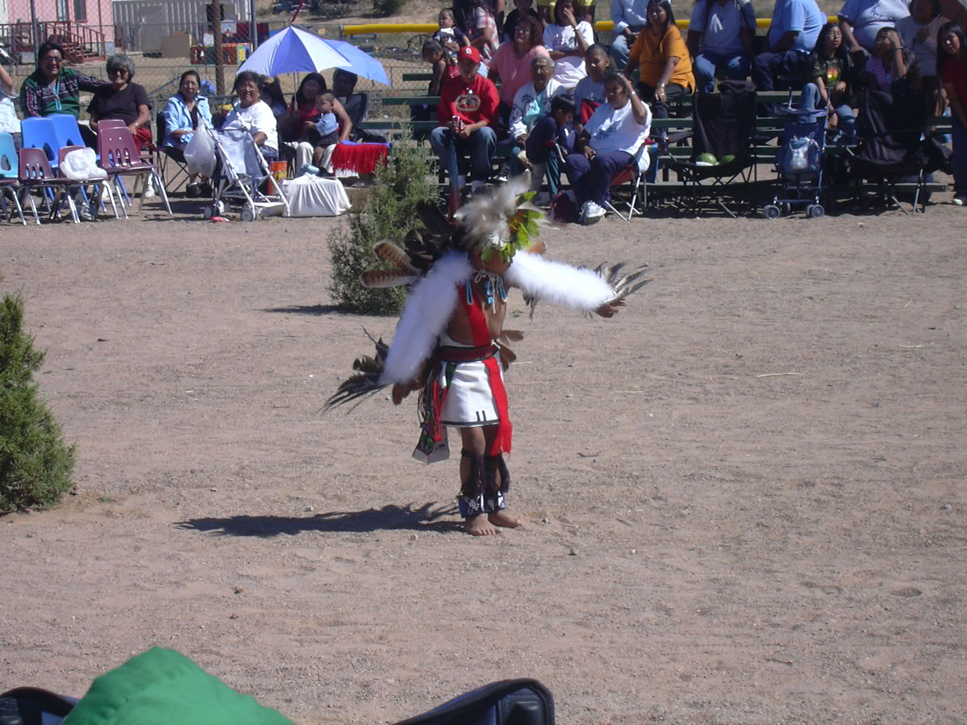
FOR HEALTH PROFESSION EDUCATORS

Syllabus DH-596
BEYOND CULTURAL DIVERSITY FOR HEALTH PROFESSION EDUCATORS
INSTRUCTOR INFORMATION

Name: Maxine Janis, RDH, MPH
Office: Health Professions Building, Room 210
Office Hours: Unavailable - Instructor Off-campus summer session
Phone: (928)523-5727

Biography: Hello! I joined Northern Arizona University, Department of Dental Hygiene in 2004 as visiting assistant professor. I received my Dental Hygiene education at Yakima Valley Community College in 1995 and a master's degree in Public Health-Health Administration and Policy in 2004 from Portland State University. Currently, I am the Director of the Hopi Project. Additionally, I teach junior and senior level dental hygiene theory and coordinate clinical rotations to the Hopi Indian Health Care Center.

COURSE INFORMATION

Course Title: Beyond Cultural Diversity
Course Number: DH599
Course Discipline: Health Science
Course Date: Monday, July 9, 2007 through Wednesday August 10, 2007

Course Prerequisites: Students must have completed their undergraduate degree to be enrolled in this graduate level course. Must have knowledge of research methodologies and apply these principles throughout the course. Students must have knowledge and skills on writing and presenting information in a concise and articulate manner.

Course Description:
Provides a background in multicontextuality and best practices for teaching all students. The concepts presented will be targeted and adapted specifically to health professions education. The course is a Web based course requiring independent thought and motivation. Active participation in online discussions is required. The textbooks, course content material and website readings will be the basis of the assignments. Students are encouraged to share their previous knowledge and professional experience regarding the course topic. Opportunities to select areas of personal interest for course assignments will be encouraged.

COURSE GOALS
After successful completion of this course, students will be able to:
- Analyze learning characteristics of the adult learner and apply the concepts to a health professions education.
- Analyze a recent health professional program/class for inclusion of diverse students within the health professional program.
- Evaluate cultural diversity variations to consider when working with health profession students and analyze current practices in place to accommodate diverse ethnicities of health discipline students.
- Apply the key characteristics of student learning styles to oneself, personal teaching styles and to students learning activities.
- Identify generational characteristics of students and apply this information to student learning.
- Analyze principals of mulicontextuality as it applies to student learning.
- Implement universal design principles into didactic and clinical teaching.
- Apply “best practice” principles within lectures, discussion, reading cooperative/collaborative learning, reflection/journaling, and problem based learning.
- Create and evaluate assessments for learning within a health discipline curriculum.
TEXTBOOKS:
McKeachie’s Teaching Tips, Wilbert J. McKeachie, Houghton Mifflin Company, Eleventh Edition, ISBN 0-618-11649-4
Strategies for Cultural Competency in Indian Health Care, Mim Dixon, Pamela E. Iron, American Public Health Association, ISBN 0-87553-070-2

Required reading: Reserved readings available online through NAU library.

INTRODUCTION

Welcome to the WEB VISTA course. All course work should be communicated through WEB VISTA
If you have computer problems, contact the Student Help Desk at 1-888-520-7215.

COURSE REQUIREMENTS
There will be two major projects due at the end of the term:

1) Research Project
A final in-depth research paper investigating concepts of multicontextuality will be required.

Method of Assessment: Students will be accessed on Researching, investigating, interpreting, organizing information, reviewing and paraphrasing information, collecting data, searching and managing information sources, observing and interpreting, and identifying bibliography sources for their final research paper. Topic “Investigating Concepts of Multicontextuality”

2) Developing a Unit of Instruction
A final course project requires the participant to create a unit of instruction utilizing the principles presented in the course.

Method of Assessment: Students will be assessed on the Designing, creating, producing a unit of instruction based on the principals presented in the graduate course applying innovative ideas in a learner-centered educational environment.

Additionally, methods of student learning outcomes will be measured through all readings and assignments. There will be feedback provided on all assignments. Through required discussions, participants will share ideas and experience. Through required journal entries, participants will reflect on concepts and consider application within their teaching area of interest.

GRADING FORMAT
All assignments and the course grade will be scored on an A-F scale as follows: A 90-100%
B 80-89%
C 70-79%
D 60-69%
F less then 59%
COURSE SCHEDULE

- Introductions
- Dimensions of Diversity
  - Learning styles
  - Gender
  - Adult learners
  - Cultural diversity considerations
  - Multicontextuality
- Promoting student understanding
  - High expectations verses minimum standards
  - Time management (time on task)
- Learner centered practices
  - Active learning
    - Reflective journaling
    - Critical thinking
  - Feedback
  - Group work verses individual work

Course Schedule Summer 2007
Suggested Date to View Topic | Module/Topic | Assignments | Date Assignment Due
Monday 7/9 | Welcome | Introduction | Sunday 7/15
Tuesday 7/10 | Generational Characteristics | Discussion Posting | Sunday 7/15
Wednesday 7/11 | Cultural Diversity | Discussion Posting | Sunday 7/15
Thursday 7/12 | Learning Styles | Journal Entry | Sunday 7/17
Friday 7/13 | Adult Learner | None
Monday 7/16 | Multicontextuality | Assignment | Sunday 7/22
Tuesday 7/17 | Self Identification | Journal Entry | Sunday 7/22
Wednesday 7/18 | -----
Thursday 7/19 | Preferred Method of Instruction | None
Friday 7/20 | Teaching Students How to Learn | Discussion Posting | Sunday 7/22
Monday 7/23 | Universal Design | Assignment | Sunday 7/29
Tuesday 7/24 | Meeting the Class | Discussion Posting | Sunday 7/29
Wednesday 7/25 | Discussion | Discussion Posting | Sunday 7/29
Thursday 7/26 | Lectures | Journal Entry | Sunday 7/29
Friday 7/27 | Reading as Active Learning | Reading Guide | Tuesday 7/31
Monday 7/30 | Reflection and Journaling | Assignment | Sunday 8/5
Tuesday 7/31 | -----
Wednesday 8/1 | Collaborative/Cooperative Learning | None
Thursday 8/2 | Technology | Discussion Posting | Sunday 8/5
Friday 8/3 | Problem Based Learning | Discussion Posting | Sunday 8/5
Monday 8/6 | Assessments  Final Research Paper  *Final Unit of Instruction Project  Class Evaluation | Final Journal Entry  *Culmination Project | Wednesday 8/8  Wednesday 8/8
Tuesday 8/7 | -----
Wednesday 8/8 | -----

DH-599 BEYOND CULTURAL DIVERSITY FOR HEALTH PROFESSION EDUCATORS
GRADING AND POINT ASSIGNMENTS
All assignments are due by 11:55 on the date posted.
Assignments will be graded as follows:
Discussions are participation points only (maximum of 10 points) 10 points possible
Journal Entries are 5 points each 15
Assignments are 10 points each 40
Final Research Paper 75
*Final Unit of Instruction Project (Culmination Project) 75

Total possible: 215

